Introduction

Wearable Technology for Health Monitoring
KHALIFA SHOAIB
Bs-AvM


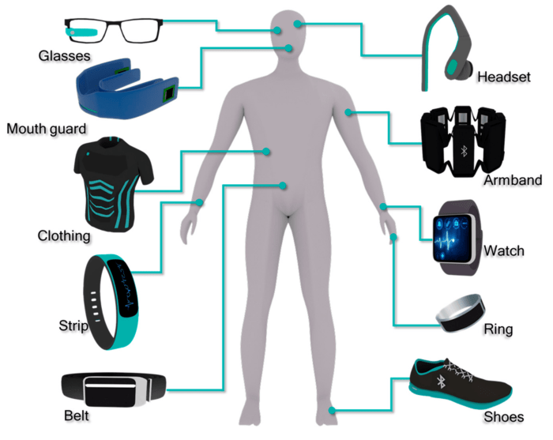
Figure 1:Introduction

Objective

The goal is to explore how wearable devices can:

1. Improve health tracking accuracy

2. Increase user engagement

3. Detect medical conditions early

In simple terms, the study wants to see how wearables can help people monitor their health better and catch potential issues sooner.

Methodology
A study was done using wearable devices (like smartwatches) to track:
1. Heart rate
2. Steps taken
3. Sleep quality
The data was collected for 2 weeks and compared to traditional clinical measurements to see how accurate and reliable the wearables were..

Experiment
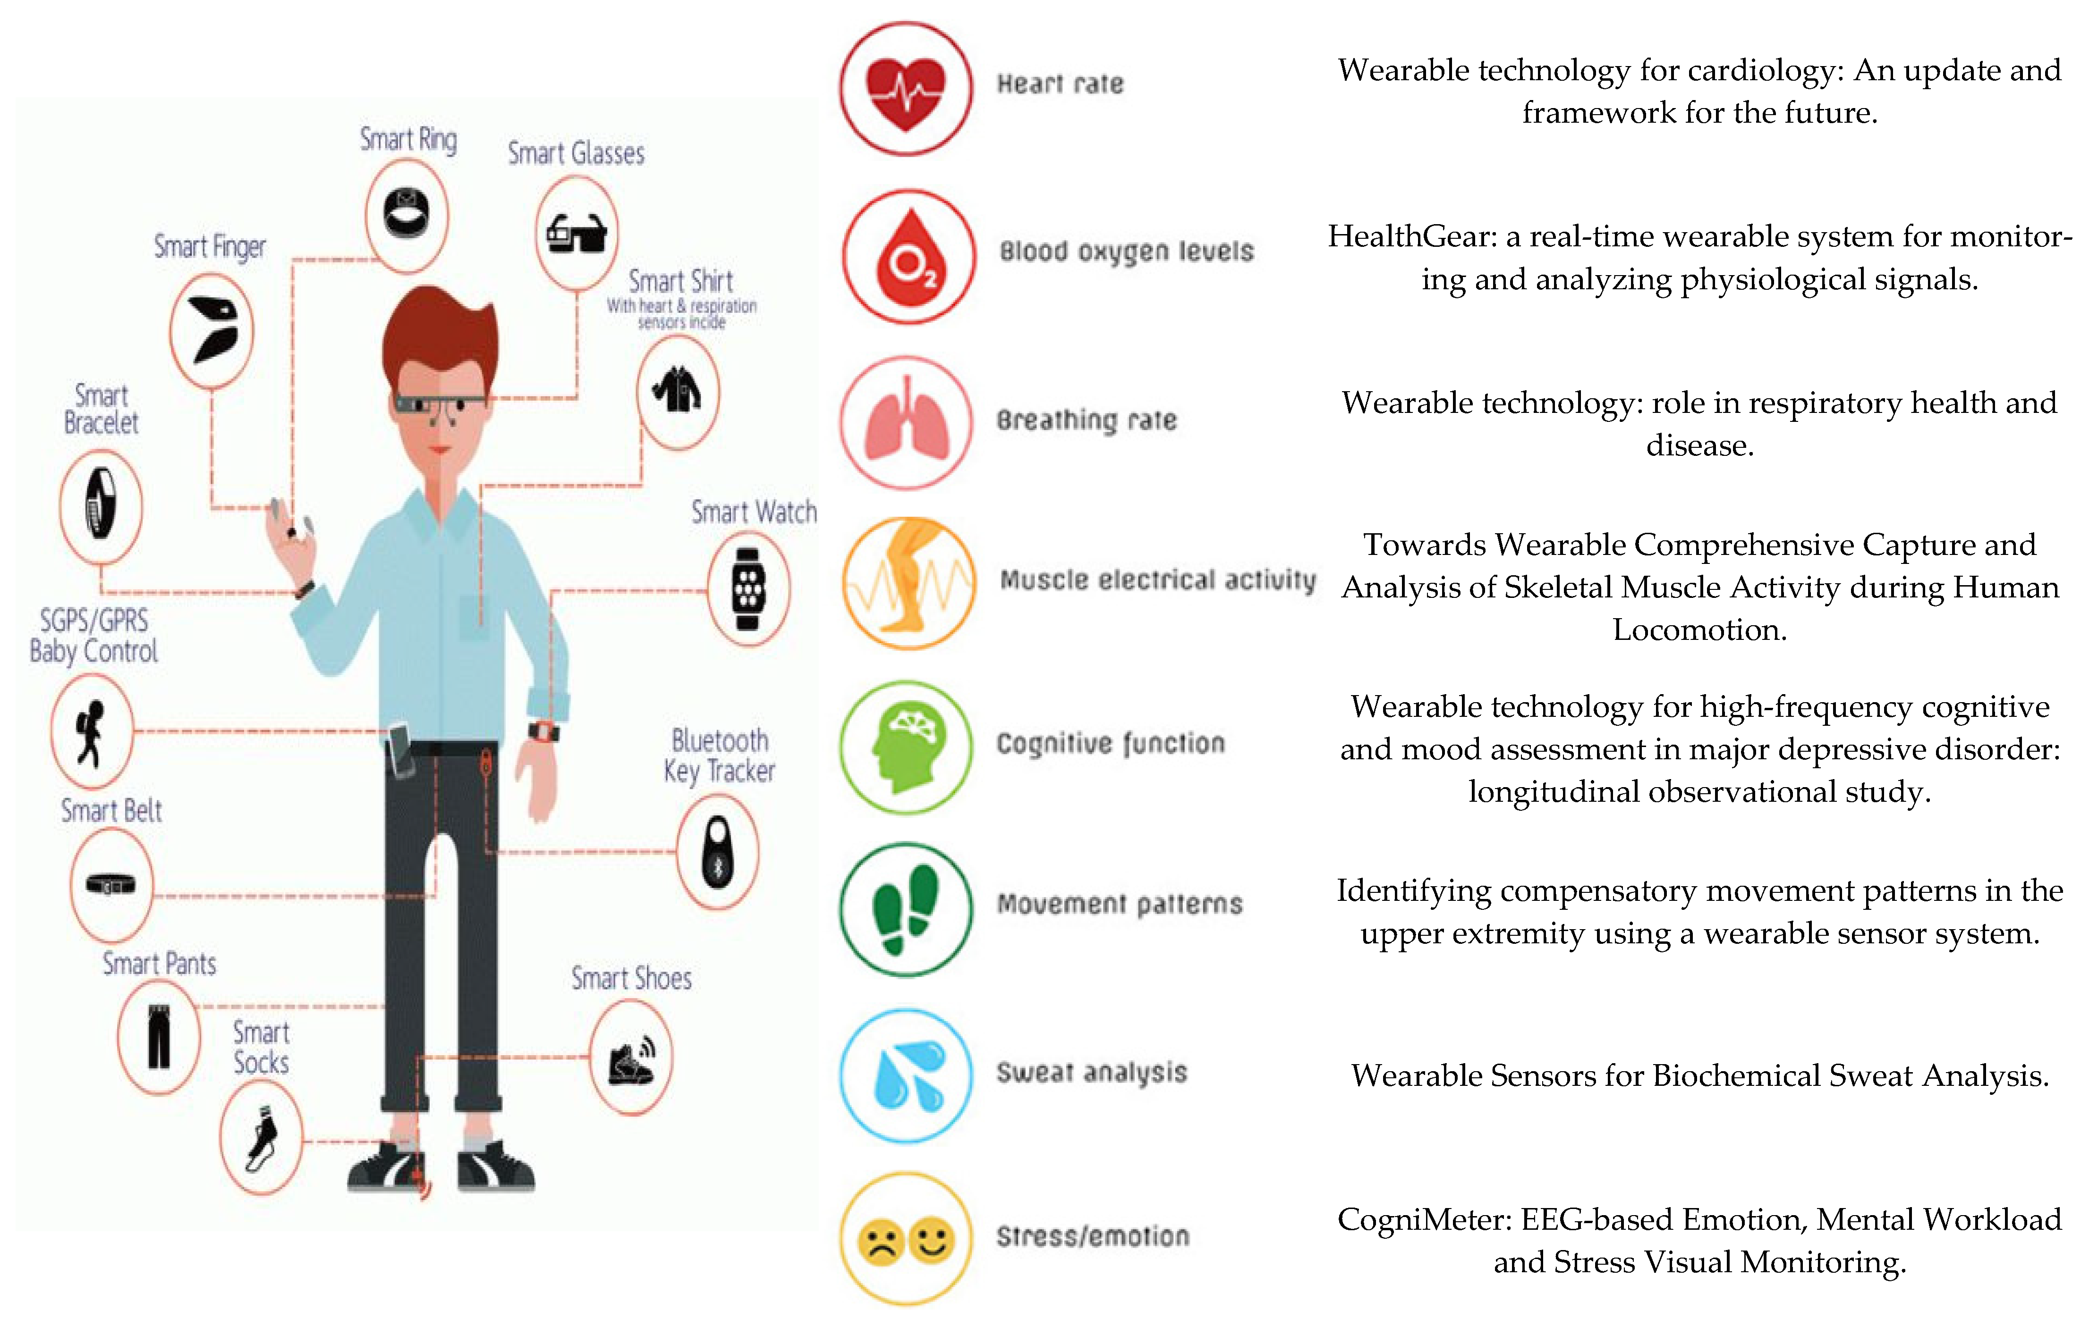
Figure 2:Experiment of Wearable Technology

KEY Findings
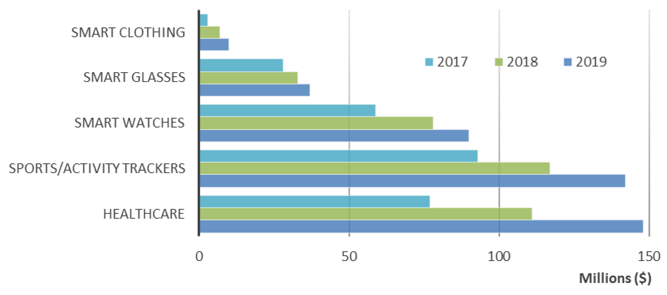
Table 1:Key Findings

Results
• High accuracy of wearables makes them reliable for daily health tracking.
• Early detection potential through continuous monitoring.
• Positive impact on user lifestyle and health awareness.

Conclusion
Wearable technology significantly enhances health monitoring by providing accurate, continuous data and promoting proactive health management. It holds promise for reducing hospital visits and supporting chronic disease management.

References
• Patel, Shwetak N., et al. "A review of wearable sensors and systems with application in rehabilitation." Journal of NeuroEngineering and Rehabilitation, 2012.
• Piwek, Lukasz, et al. "The rise of consumer health wearables: Promises and barriers." PLOS Medicine, 2016.

